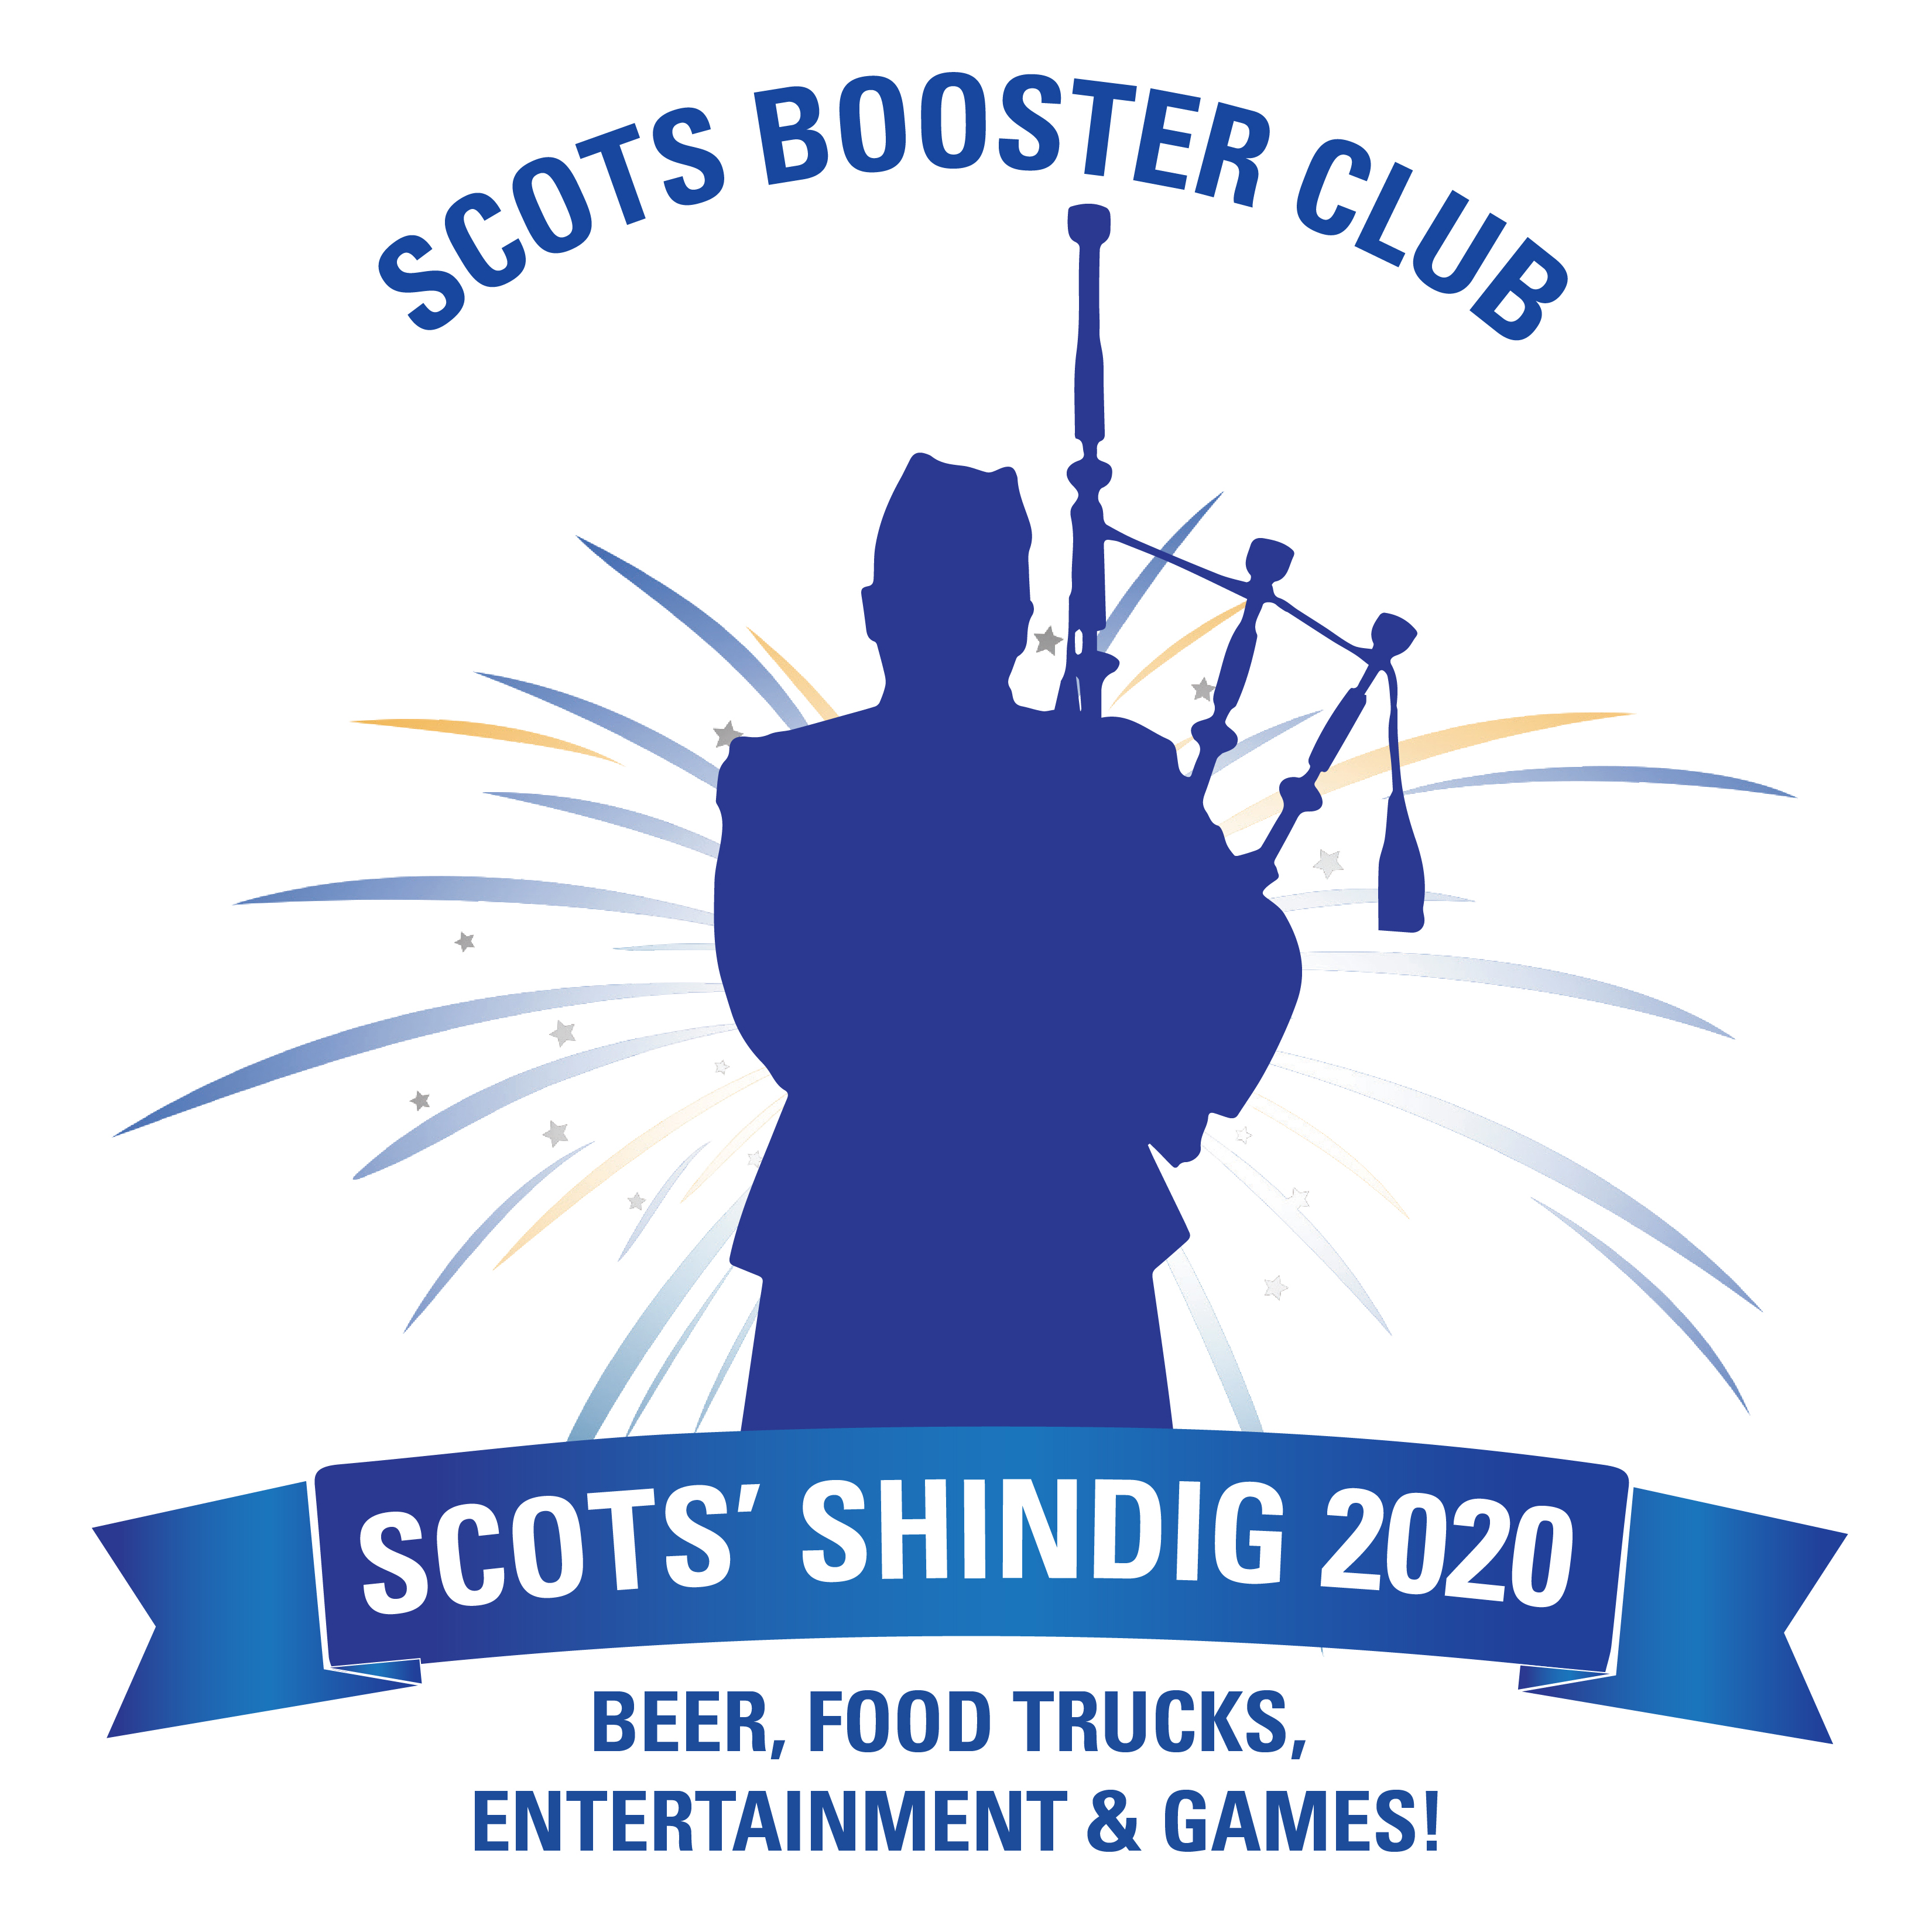
Scots’ Shindig Sponsorship Form

Donor Name/Company______________________________________________________________________________
Contact Person_______________________________________ Company Website ______________________________
E-mail ___________________________________________________ Phone___________________________________
Address _______________________________________ City______________________ State______ Zip___________

Scots’ Shindig Sponsor Levels
Scots’ Shindig Event Program:
The Scots' Shindig is the ONE AND ONLY FUNDRAISER hosted by the Carlmont Scots Booster Club. The Scots’ Shindig is a one-of-a-kind event that brings together people from all over our community to raise funds for all 23 of Carlmont's athletic programs. Here are the donation levels for the Scots’ Shindig.

- $750 Platinum Sponsor
Includes 4 complimentary Scots’ Shindig dinner tickets for our event at Devil’s Canyon on 5/2/20 from 6-10PM, full page ad in event program, listing in the program, website, and event signage.
- $500 Gold Sponsor
Includes 2 complimentary Scots’ Shindig dinner tickets, business card-sized ad in event program, listing in program, website, and event signage.
- $250 Silver Sponsor
Includes 1 complimentary Scots’ Shindig dinner ticket, listing in event program, website, and event signage.

$_______________ Total Sponsorship Enclosed
Make checks payable to Carlmont Scots Booster Club, 1400 Alameda de las Pulgas, Belmont, CA 94002.
You can also purchase a sponsorship online at https://carlmont.ejoinme.org/Shindig2020.
Questions about sponsorship or to submit Shindig artwork, contact Kathryn Zorb katzorb@yahoo.com

Thank you for your BOOST to our athletics program!

